**So now let’s get started**

So now the two devices which I am going to compare in this whole report are

1. Vivo Y71
2. Vivo Z1 Pro

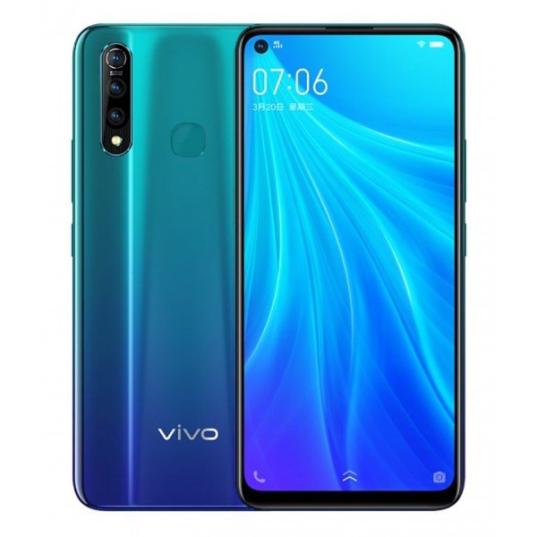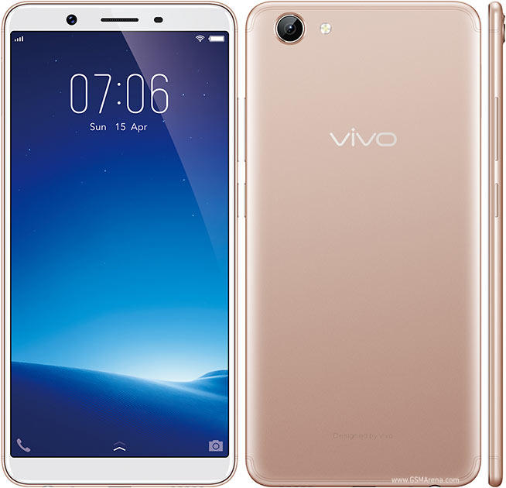

Vivo Z1 Pro

Vivo Y71

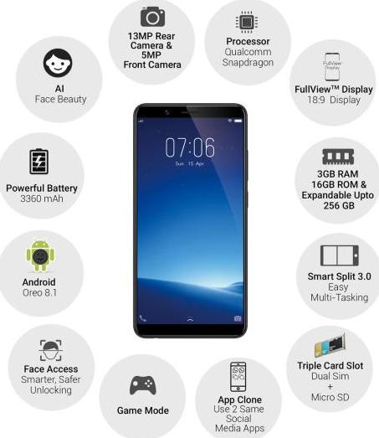**Pictorial representation of the features of Vivo Y71**

**Product Description – Vivo Y71**

With a FullView Display, powerful Qualcomm Snapdragon Quad-core Processor, and 3360 mAh battery, the Vivo Y71 smartphone has been created to impress you with an immersive visual experience, lag-free multitasking, and uninterrupted performance.

* 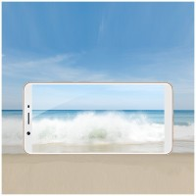**15.21 cm (6) FullView HD+ Display**

The 18:9 FullView Display comes with a narrow bezel and a screen-to-body ratio of 84.4 percent. As a result, you can enjoy an immersive visual experience on this compact and lightweight smartphone. It also makes it that is easy to carry and operate using one hand.

* **13 MP Rear Camera for Vivid Photos**

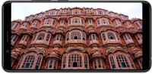The rear camera comes with a fast focus feature to capture even the fleeting moments with crystal clarity. It also manipulates the ambient light to click clear, vibrant, and beautiful photos, even at night. Also, once you're done clicking photos and taking videos, you need not worry about storage, as this smartphone comes with 16 GB of ROM. To further address your storage woes, you can expand the internal memory by up to 256 GB using a microSD card.

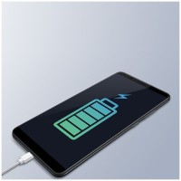

* **Extended Battery Life**

The 3360 mAh battery, along with advanced Android 8.1 OS optimization, offers energy-efficient and uninterrupted performance without the need to charge this phone frequently. This smartphone also comes with the Vivo Smart Engine to provide you with additional power management.

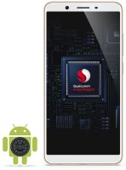

* **Qualcomm Snapdragon 425 Processor for Powerful Performance**

The powerful 1.4 GHz quad-core processor, along with 3 GB of RAM and an Adreno 308 GPU, offers a seamless performance. This smartphone also performs defragmentation and memory optimization tasks to ensure a smooth operation. To top it off, this device runs on the Android Oreo 8.1 OS that offers impressive battery life and improved security.

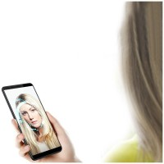

* **AI Face Access to Unlock Your Smartphone**

When the screen of Vivo Y71 is activated, it scans your facial features and unlocks the device. This security feature ensures that your device acts more like a loyal friend that recognises your face at a glance, than just a smartphone.

* **AI Technology for Awe-inspiring Selfies**

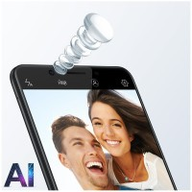This Vivo smartphone identifies your age, gender, skin tone and texture to add various beauty effects, making you look more stunning in each selfie. Also, over time, this device understands your face and photographic habits to enhance the quality of your selfies.

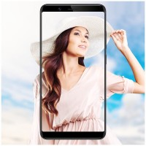

* **Backlight HDR for Bright Photos**

It optimises ambient lighting for the face to click bright and clear images.

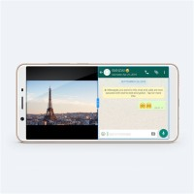

* **Smart Split for Easy Multitasking**

This feature helps you multitask easily on the 15.21 cm (6) display. You can chat with friends and watch a viral video simultaneously, without compromising on the video quality or text space.

**Pictorial representation of the features of Vivo Z1 Pro**

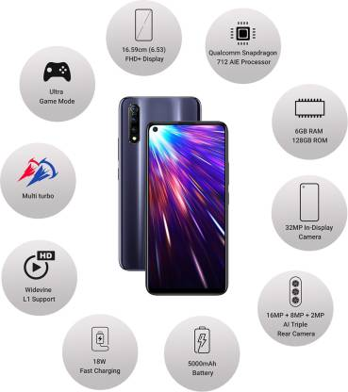

**Product Description – Vivo Z1 Pro**

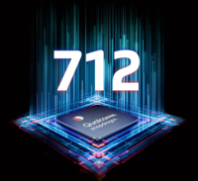

* **Mighty Performance**

Powered by the Qualcomm Snapdragon 712 AIE processor and 6 GB of RAM, this phone can handle any task seamlessly. The advanced 10-nm design, a clock speed of up to 2.3 GHz and Adreno 616 Graphic Processing Unit (GPU) let you game and multitask easily. It comes with 128 GB of internal memory so that you can store loads of pictures, videos and other files.

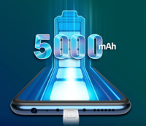

* **Powerful Battery with 18 W Fast Charging**

Housing a 5000-mAh battery, this phone has enough juice to let you complete multiple tasks in one sitting. And, it is just 8.85 mm thick. The 18 W Fast Charger powers up your phone in no time. Also, it supports the OTG reverse charging function, making charging hassle-free.

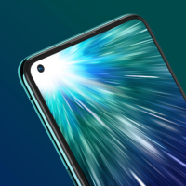

* **32 MP In-Display Front Camera**

This camera, which has an aperture ratio of f/2.0, lets you click gorgeous selfies. With modes and features such as HDR Mode, AR stickers, Portrait light effects, Live Photo, AI Beauty, and Fun Video, you can up your selfie game.

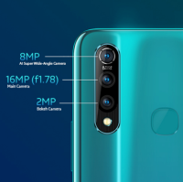

* **AI Triple Rear Camera**

The triple rear camera setup, comprising a 16 MP (aperture ratio of f/1.78) Main Camera, 8 MP Super Wide-Angle Camera and a 2 MP Depth Camera, lets you capture stunning pictures of scenic views. You can not only capture mesmerising photos and videos effortlessly, but share them instantly too.

* **AI Super Wide-angle Camera**

Capture more of the world with this camera that expands your frame’s view 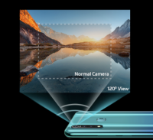by up to 120 degrees. Now, you can include your entire squad and more of the landscape in your pictures.

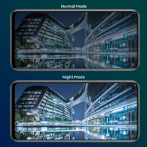

* **Night Mode**

Take stunning pictures in brightly lit cafes and dimly lit pubs. This mode lets you capture clear pictures, even when the lighting conditions are dark.

* **Multi-Turbo**

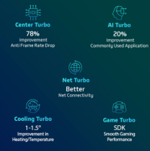The feature comprises the Net Turbo, Center Turbo, AI Turbo and Cooling Turbo functions. The Net Turbo feature maintains better network status, whereas the Center Turbo feature keeps the game’s CPU and memory resources smooth. The AI Turbo feature recognises your usage pattern and facilitates the faster opening of common applications. The Cooling Turbo features brings down the temperature on the surface to ensure that the performance of the phone is seamless, even during intense gaming sessions.

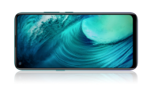

* **16.59 cm (6.53) FHD+ Display**

The FHD+ display, 90.77% screen-to-body ratio and 19.5:9 super-wide view give you a vivid and lifelike viewing experience.

**NETWORK SETTINGS**

Vivo Y71

1. **Technology** : It consists of four types:
   1. **GSM:**

GSM an acronym for Global System for Mobile Communications, is a mobile network standard with worldwide support for mobile phones. This standard was crafted by the European Telecommunications Standards. GSM serves as the first second-generation (2G) telecommunications standard with support for digital devices, unlike the 1G cellular network.

Initially, GSM phones focused on the transmission of voice data, but with time, GPRS (in 2000) and EDGE (in 2003) came into the picture to expand its capabilities to packet data transport, bringing about internet access.

The 2G bands used by GSM include 850MHz, 900MHz, 1800MHz and 1900MHz. The bands used mostly in countries are the 850MHz and 1800MHz bands.

* 1. **CDMA (Code – division Multiple Access):**

This type of network standard opens the pathway for multiple radio technologies to communicate data over it without interference. Its style of operation is known as Multiple Access Method. The interference is avoided due to the implementation of a spread spectrum technology that assigns a code to each transmitter. Ideally, CDMA comprises CDMAOne, CDMA2000 and W-CDMA. The CDMAOne is also referred to as IS95 which is a second-generation network standard. CDMA2000 and W-CDMA(Wideband CDMA) are both based on the third-generation (3G) technologies.

* 1. **HSPA (High Speed Packet Access):**

Importantly, HSPA is composed of HSDPA and HSUPA. HSDPA represents High Speed Downlink Packet Access while HSUPA stands for High Speed Uplink Packet Access. Although the HSPA uses 3G standards, it delivers higher data transmissions when compared to the CDMA technologies. HSPA was primed at improving 3G standards on CDMA communication protocol.

* 1. **LTE (Long-Term Evolution):**

LTE is popularly called “4G LTE”. According to the standards that were set for true 4G technologies, the LTE network doesn’t meet up. But to cut out confusions arising from different models like 3.9G, it was issued that LTE gets marketed as 4G LTE.

Currently, it is the standard with the highest internet speed across the globe. It boasts of download speeds of about 150Mbps – 300Mbps.

|  |  |  |  |
| --- | --- | --- | --- |
| **NETWORK** | **Technology** | Vivo Y71 | Vivo Z1 Pro |
| GSM / HSPA / LTE | GSM / CDMA / HSPA / LTE |

# Network coverage:

A key part of any mobile phone specification is its operating frequency bands. The supported frequency bands determine whether a certain handset is compatible with a certain network carrier.

Beside the mobile phone specifications, GSMArena is happy to also provide you with its own country-based frequency band directory. It's not operator-specific and it's helpful if you are choosing a handset to use in your home country or if you are making sure your phone will work in the country you are heading to.

|  |  |
| --- | --- |
| 2G capabilities | GSM 900, GSM 1800 |

|  |  |
| --- | --- |
| 3G capabilities | UMTS 900, UMTS 2100 |

|  |  |
| --- | --- |
| 4G capabilities | LTE 850 (5), LTE 1800 (3), LTE 2100 (1), LTE 2300 (40), LTE 2500 (41) |

**2G**, first introduced in 1992, is the second-generation of cellular telephone technology and the first to use digital encryption of conversations. 2G networks were the first to offer data services and SMS text messaging, but their data transfer rates are lower than those of their successors.

**3G,** networks succeed 2G ones, offering faster data transfer rates and are the first to enable video calls. This makes them especially suitable for use in modern smartphones, which require constant high-speed internet connection for many of their applications.

**4G,** is the fourth generation of mobile phone communications standards. It is a successor of the 3G and provides ultra-broadband internet access for mobile devices. The high data transfer rates make 4G networks suitable for use in USB wireless modems for laptops and even home internet access.

|  |  |  |  |  |
| --- | --- | --- | --- | --- |
|  | **NETWORKS** |  | Vivo Y71 | Vivo Z1 Pro |
|  | **2G bands** | GSM 900 / 1800 - SIM 1 & SIM 2 | GSM 850 / 900 / 1800 / 1900 - SIM 1 & SIM 2 |
|  |  |  | CDMA 800 & TD-SCDMA |
|  | **3G Network** | HSDPA 850 / 900 / 2100 | HSDPA 850 / 900 / 2100 |
|  | **4G Network** | LTE band 1(2100), 3(1800), 5(850), 8(900), 38(2600), 40(2300), 41(2500) | LTE band 1(2100), 3(1800), 4(1700/2100), 5(850), 8(900), 34(2000), 38(2600), 39(1900), 40(2300), 41(2500) |
|  | **Speed** | HSPA, LTE | HSPA 42.2/5.76 Mbps, LTE-A |

# Phone Life Cycle

# The stage of a phone within its life cycle as we report it within our Phone specifications page here at GSMArena.

There are five different stages to a phones life cycle.

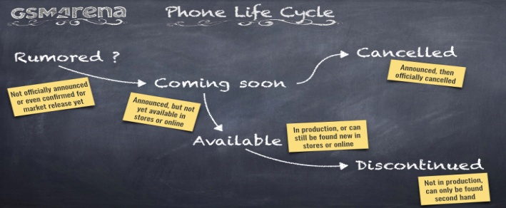

**Rumored**

Not yet officially announced or even confirmed for market release yet. You'll notice that we're very enthusiastic on reporting on rumors for upcoming phone releases.

### Coming Soon

Officially announced, but not yet available to buy in stores or online. However, it may be available for pre-order. We include the announcement date within our Phone Specifications page

### Cancelled

Officially announced, and then officially cancelled. Rarely happens.

### Available

In production, can be found new in stores and online. Availability could vary by region though.

### Discontinued

No longer in production, can usually be found pre-owned online.

|  |  |  |  |
| --- | --- | --- | --- |
| **LAUNCH** |  | Vivo Y71 | Vivo Z1 Pro |
| **Announced** | 2018, April | 2019, July |
| **Status** | Available. Released 2018, April | Available. Released 2019, July |

1. **Body of the mobile:**
   1. **Dimensions:**

|  |  |  |  |
| --- | --- | --- | --- |
| **BODY** |  | Vivo Y71 | Vivo Z1 Pro |
| **Dimensions** | 155.9 x 75.7 x 7.8 mm (6.14 x 2.98 x 0.31 in) | 162.4 x 77.3 x 8.9 mm (6.39 x 3.04 x 0.35 in) |
|  | https://in-exstatic-vivofs.vivo.com/gdHFRinHEMrj3yPG/20181018/916612fd2d6e76ab336c0229493e2dfa.jpg | https://in-exstatic-vivofs.vivo.com/gdHFRinHEMrj3yPG/1561690827865/cee11c2e0569557d862fa5fadf071f2b.jpg |

# Construction

# Describes the construction materials, methods and finishes used by the manufacturer when building a phone.

As with the fashion world, every new season (or phone launch) introduces new or elaborately names colors. Kinda Blue anyone? With the color being influenced in its final appearance by those materials chosen.

Each material used has unique properties that are both advantageous and complimentary to the device but often come with limitations.

For example, a glass body allows radio waves to pass through and better facilitates wireless charging, but unless utilized properly, could make the phone more fragile.

Recent construction trends include the use of aluminium, glass and even ceramics.

In order to make the display as resilient as possible, many manufactures use Corning Gorilla Glass.

A devices ability to withstand dust and moisture is identified via a IP Rating.

|  |  |  |  |
| --- | --- | --- | --- |
| **BODY** |  | Vivo Y71 | Vivo Z1 Pro |
| **Build** | Front glass, aluminum body | Plastic Body |

1. **SIM**

A subscriber identity module is a removable smart card for mobile phones. SIM cards store the required information to identify the mobile device. It also contains data required for voice encryption to make listening in on calls almost impossible (except when the wireless carrier itself is doing the eavesdropping).

In this way the customer ID (and personal number) is tied to the SIM card and not to a certain mobile phone. This allows for a seamless interchange of the same SIM card between different GSM mobile phones.

SIM cards also serve as storage for SMS messages and the user's contacts. Current SIM cards can store up to 250 name/number pairs and up to 50 SMS text messages.

The SIM card cannot store multiple numbers per contact or other more complex information. This means that if you copy your contacts info from the phone memory to the SIM memory, contacts get broken up into as many entries as there are numbers for each individual contact and discards the other information.

All GSM phones and most iDEN phones require a SIM card to operate.

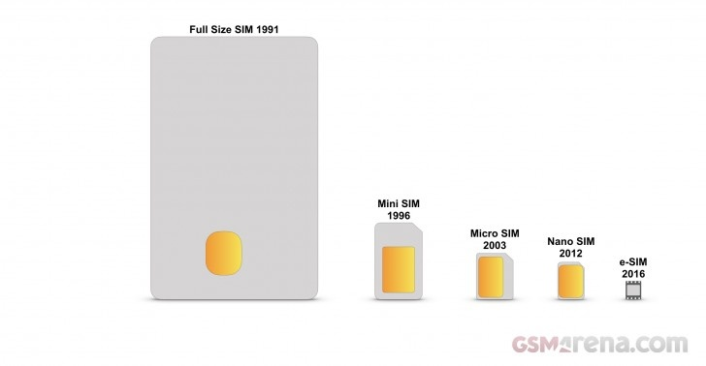There are certain types of phones (CDMA, TDMA, AMPS) that do not use a SIM. Instead, the required data is programmed directly into the phone.

Replaceable SIM cards come in four standard sizes:

* **Full-size** (85.6mm × 53.98mm × 0.76 mm)
* **Mini-SIM** (25mm x 15mm x 0.76mm)
* **Micro-SIM** (15mm x 12mm x 0.76mm)
* **Nano-SIM** (12.3mm × 8.8mm × 0.67mm)

The eSIM or Embedded SIM comes in one size:

* **eSIM** (6mm x 5mm x <1mm) Non Removable

The first to appear was the full-size or 1FF (1st Form Factor), the size of a credit card (85.60 mm × 53.98 mm × 0.76 mm). It was followed by a mini-SIM or 2FF (2nd Form Factor), which has the same thickness but is 25 mm long by 15 mm wide, with one of its corners cut to prevent misinsertion. Next came micro-SIM or 3FF (3rd Form Factor), with dimensions of 15 mm × 12 mm.

In 2012 the nano-SIM or 4FF (4th Form Factor) was introduced, which measures 12.3 × 8.8 × 0.67 mm. Nano-SIM cards can use adapters to gain compatibility with devices with Micro-SIM and Mini-SIM slots. A Micro-SIM card can also be fitted in Mini-SIM slot with an adapter.

In 2016 the eSIM/Embedded SIM, or as it's more formally known, embedded Universal Integrated Circuit Card (eUICC) was introduced. It is soldered onto a device's motherboard at the point of manufacturing while having the same functionality as a removable SIM.

There are two numeric passwords associated with a SIM card. One is the Personal Identification Number (PIN) that the user must input each time they start the device (this can be turned off via the phone settings).

|  |  |  |  |
| --- | --- | --- | --- |
| BODY |  | Vivo Y71 | Vivo Z1 Pro |
| SIM | Dual SIM (Nano-SIM, dual stand-by) | Dual SIM (Nano-SIM, dual stand-by) |

When entering the PIN number the user has only three input attempts. If all three are incorrect, the card gets locked and a PUK (Personal Unblocking Key) must be entered in order for the card to work again. Only ten attempts to enter the PUK are permitted before the card is permanently locked and made unusable.

# Display :

# Types:

There are many display/panel types used in smartphones today.

These include:

* LCD (Liquid Crystal Display)
* IPS-LCD (In-Plane Switching Liquid Crystal Display)
* OLED (Organic Light-Emitting Diode)
* AMOLED (Active-Matrix Organic Light-Emitting Diode)

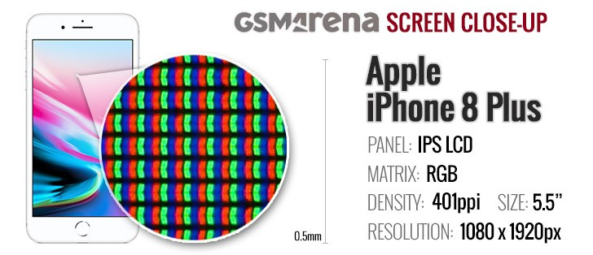The screen, when combined with the touch element, is 'the' major element of the user interface and as such we go to great lengths when testing screens during our review process to measure a displays quality by measuring Contrast Ratio, Color Calibration, Brightness and Sunlight Legibility.

### LCD/IPS-LCDs

LCD (Liquid Crystal Display) displays consist of a matrix of Liquid Crystals. Liquid Crystals do not emit light themselves and are reliant on some form of back-light to illuminate the whole display. As a result LCD displays can be very visible in direct sunlight.

IPS-LCDs provide a superior viewing angle and better color reproduction than non IPS-LCDs due to the layout of the LCD's themselves. This has become a common display type for mid-range to high-end phones.

**Our tests show the IPS-LCD matrix in detail for the iPhone 8 Plus**

### https://fdn.gsmarena.com/imgroot/static/glossary/display-type/gsmarena_002.jpgOLED/AMOLED

OLED & AMOLED utilizes 'organic' LEDs which emits light and in the majority of cases does away with the need for the back-light of an LCD display resulting in a potentially thinner panel. It provides less washed out 'blacks' with a better contrast ration and is highly visible in low light conditions.

They consume less power as opposed to LCDs which always have the back-light on. When a pixel is 'black' on a OLED/AMOLED display the pixel is truly off.

**When magnified, the differences between panel types are clear**

|  |  |  |  |
| --- | --- | --- | --- |
| **DISPLAY** |  | Vivo Y71 | Vivo Z1 Pro |
| **Type** | IPS LCD capacitive touchscreen, 16M colors | IPS LCD capacitive touchscreen, 16M colors |
| **Size** | 6.53 inches, 104.7 cm2 (~83.4% screen-to-body ratio) | 6.0 inches, 92.9 cm2 (~78.7% screen-to-body ratio) |

# Resolution:

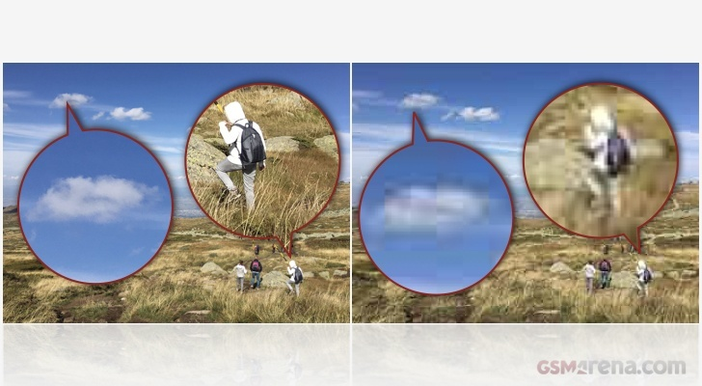A term that refers to the number of pixels on a display or in a camera sensor (specifically in a digital image). A higher resolution means more pixels and more pixels provide the ability to display more visual information (resulting in greater clarity and more detail).

### Standard Display Resolution Sizes

The industry standard way of representing screen resolution is publishing the number of pixels that form the two sides of the display rectangle.

A number of standards currently exist when it comes to display resolutions:

|  |  |
| --- | --- |
| Name(s) | Resolution in pixels |
| High Definition (HD) | 1280 x 720 |
| Full HD, FHD | 1920 x 1080 |
| 2K, Quad HD, QHD | 2560 x 1440 |
| 4K, Ultra HD | 3840 x 2160 |

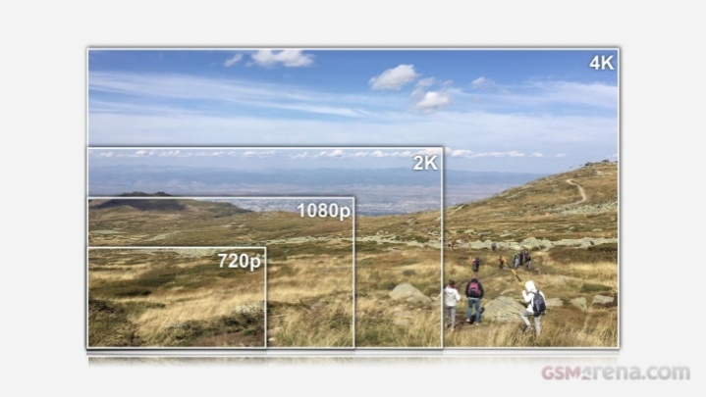

When launched in 2007, the original iPhone came with a screen resolution of 320 pixels x 480 pixels.

Resolution does not refer to the physical size of the display, camera sensor or image. For example, two displays with the same resolution can have different physical dimensions. Hence the importance of the other parameter that we publish - pixel density, which is measured in pixels-per-inch (ppi). Since a smaller display of the same resolution will have more pixels per inch the image provided by it should be clearer and more detailed (although graphics will be physically smaller).

**Standard display sizes compared**

|  |  |  |  |
| --- | --- | --- | --- |
| **DISPLAY** |  | Vivo Y71 | Vivo Z1 Pro |
| **Resolution** | 720 x 1440 pixels, 18:9 ratio (~268 ppi density) | 1080 x 2340 pixels, 19.5:9 ratio (~395 ppi density) |

**Screen protection** - definition

As touch screen displays are growing larger in recent years, the need for enhanced scratch resistance and protection of the screens created the demand for usage of screen covers of increased resistance including chemically hardened glass.

Corning's Gorilla Glass is a popular brand of hardened glass used for high-end handset in the mobile industry.

Additionally, manufacturers has started applying oleophobic coating on top of its screens to make finger smudges less of an issue.

|  |  |  |  |
| --- | --- | --- | --- |
| **DISPLAY** |  | Vivo Y71 | Vivo Z1Pro |
| **Protection** | Corning Gorilla Glass 3 | Tempered Glass |

1. **Platform:**
   1. **OS (Operating System)**

The Operating System is a base infrastructure software component of a computerized system. It controls all basic operations of the computer (or other electronic devices such as PDA, smartphone, etc.). The Operating System allows the user to install and execute third-party applications (commonly called apps for short), usually adding new functionality to the device.

Among the most popular computer operating systems are Microsoft's Windows and Apple's MacOS, along with the various distributions of Linux.

The most popular OS's for mobile devices (smartphones and tablets) are Apple's iOS and Google's Android and they are the only ones that still show growth. Down the ranks there are RIM's BlackBerry OS and Microsoft's Windows Mobile. Symbian holds a distant fifth place, while it wasn't that long ago it was still the most widely used mobile OS.

Symbian held its top position for years but its market share has been slowly fading away ever since touch-operated smartphones became the norm and Symbian failed to deliver an intuitive touch UI. Almost ten years ago, Microsoft's Windows Mobile was a strong player too, offering the first touchscreen smartphone experience with the PocketPCs powered by their OS.

More recent Blackberry phones use the Android OS with added Blackberry security features.

On October 8th 2017, Microsoft stated that whilst they will support the Windows Mobile platform, they will cease development on any new features.

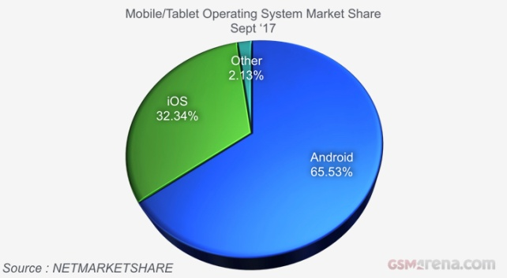Today mobile devices with a proper OS are called smartphones and users have a wide choice of applications, such as games, productivity apps, communication or social media apps, digital maps, etc.

Standardized operating system platforms make it possible to provide a consistent user interface (and experience) across devices from different hardware manufacturers. Yet, Android smartphone manufacturers like to customize the user experience so each offers a slightly modified version of the stock Android UI.

While the major players these days are clear, over the years we've seen the emergence of numerous mobile OS projects including but not limited to Palm's webOS, Samsung's Bada OS, Nokia's Maemo OS, Nokia's MeeGo OS, LiMo OS, Tizen, BlackBerry's Playbook OS and more recently, the Jolla's Sailfish OS and Mozilla's Firefox OS.

**Android & iOS dominate market share**

|  |  |  |  |
| --- | --- | --- | --- |
| **PLATFORM** |  | Vivo Y71 | VivoZ1 Pro |
| **OS** | Android 8.1 (Oreo); Funtouch 4 | Android 9.0 (Pie); Funtouch 9 |

1. **Chipset**

Mobile phones run on so-called embedded chipsets, which are designed to perform one or a few dedicated functions, often with real-time computing constraints. They are embedded as part of the complete device including hardware and mechanical parts.

The ever popular smartphones are equipped with more advanced embedded chipsets that can do many different tasks depending on their programming.

Thus their CPU (Central Processing Unit) performance is vital for the daily user experience and people tend to use the clock rate of the main CPU that's in the heart of the chipset to compare the performance of competing end products.

As we already pointed out, the clock rate of a processor is only useful for providing performance comparisons between computer chips in the same processor family and generation.

Also, as mobile gaming is increasingly gaining popularity, users have become more aware of the various types of GPU (Graphics Processing Unit) chips that come as part of the mobile chipsets and sometimes even consider their performance when making buying decisions.

|  |  |  |  |
| --- | --- | --- | --- |
|  |  | Vivo Y71 | Vivo Z1 Pro |
| **PLATFORM** | **Chipset** | Qualcomm MSM8917 Snapdragon 425 (28 nm) | Qualcomm SDM712 Snapdragon 712 (10 nm) |

1. **CPU (Central Processing Unit)**

CPU (Central Processing Unit) - otherwise known as a processor - is an electronic circuit that can execute computer programs. Both the miniaturization and standardization of CPUs have increased their presence far beyond the limited application of dedicated computing machines. Modern microprocessors appear in everything from automobiles to mobile phones.

The clock rate is one of the main characteristics of the CPU when performance is concerned. Clock rate is the fundamental rate in cycles per second (measured in hertz, kilohertz, megahertz or gigahertz) for the frequency of the clock in any synchronous circuit. A single clock cycle (typically shorter than a nanosecond in modern non-embedded microprocessors) toggles between a logical zero and a logical one state.

With any particular CPU, replacing the crystal with another crystal that oscillates with twice the frequency will generally make the CPU run with twice the performance. It will also make the CPU produce roughly twice the amount of waste heat.

Engineers are working hard to push the boundaries of the current architectures and are constantly searching for new ways to design CPUs that tick a little quicker or use slightly less energy per clock. This produces new cooler CPUs that can run at higher clock rates.

Scientists also continue to search for new designs that allow CPUs to run at the same or at a lower clock rate as older CPUs, but which get more instructions completed per clock cycle.

The clock rate of a processor is only useful for providing comparisons between computer chips in the same processor family and generation.

Clock rates can be very misleading since the amount of work different computer chips can do in one cycle varies. Clock rates should not be used when comparing different computers or different processor families. Rather, some kind of software benchmarks should be used.

Smartphones are equipped with more advanced embedded chipsets that can do many different tasks depending on their programming.

|  |  |  |  |
| --- | --- | --- | --- |
| **PLATFORM** |  | Vivo Y71 | Vivo Z1 Pro |
| **CPU** | Quad-core 1.4 GHz Cortex-A53 | Octa-core (2x2.3 GHz Kryo 360 Gold & 6x1.7 GHz Kryo 360 Silver) |

The performance of the CPU that's at the core of the chipset is vital for the daily user experience and the general computing performance of the smartphone. People tend to use the clock rate of the main CPU to compare the performance of competing end products. But as we already pointed out, the clock rate of a processor is only useful for providing performance comparisons between computer chips in the same processor family and generation. For all other purposes, it's best to use software benchmarks for determining comparative performance

1. **GPU (Graphics Processing Unit)**

The GPU (Graphics Processing Unit) is a specialized circuit designed to accelerate the image output in a frame buffer intended for output to a display.

GPUs are very efficient at manipulating computer graphics and are generally more effective than general-purpose CPUs for algorithms where processing of large blocks of data is done in parallel.

|  |  |  |  |
| --- | --- | --- | --- |
| **PLATFORM** |  | Vivo Y71 | Vivo Z1 Pro |
| **GPU** | Adreno 308 | Adreno 616 |

Modern smartphones are equipped with advanced embedded chipsets that can do many different tasks depending on their programming. GPUs are an essential part of those chipsets and as mobile games are pushing the boundaries of their capabilities, the GPU performance is becoming increasingly important.

1. **Memory Management**
2. **Memory card slot**

A special slot for inserting a memory card. Memory cards allow you to expand the phone's built-in memory (or in the past these slots have been used to add some missing features such as Wi-Fi connectivity).

Memory cards have different capacities and are used to store and transfer files between compatible devices. There are several types of memory cards. The most popular and frequently used by mobile phone manufacturers is microSD; however, up until recently Sony Ericsson exclusively used the Memory Stick Micro (M2) card type developed by Sony.

Memory card slots can have various supported memory card capacities. Depending on the device, card slots can support capacities of up to 2, 4, 8, 16 or even the yet unavailable 32GB.

As manufacturers rarely test their products for compatibility with newer and larger cards that come out after a specific handset is out on the market, whenever it is possible, we try to verify that larger capacity cards run on older phones.

When we confirm that a mobile phone works with a larger capacity memory card than what the manufacturer has advertized, we usually put that down in the phone specs sheet in our database.

That way, when you see the word "verified" in the Card slot field, you will know our reviewing team has personally tested the device for compatibility with the stated capacity and they are compatible even though it may not be officially stated so by the manufacturer.

Still, you should take that information with a pinch of salt, as your mileage with your specific unit may vary.

|  |  |  |  |
| --- | --- | --- | --- |
| **MEMORY** |  | Vivo Y71 | Vivo Z1Pro |
| **Card slot** | microSD, up to 256 GB | microSD, up to 256 GB (dedicated slot) |

1. **Dynamic Memory**

A way or organizing different types of data in the phone's memory. Also referred to as Shared memory.

Dynamic memory means that all types of data are stored in the same memory (there is no separate memory for photos, ringtones etc.).

|  |  |  |  |
| --- | --- | --- | --- |
| **MEMORY** |  | Vivo Y71 | Vivo Z1 Pro |
| [**Internal**](https://www.gsmarena.com/glossary.php3?term=dynamic-memory) | 128 GB, 6 GB RAM or 64 GB, 6/4 GB RAM | 16/32 GB, 3 GB RAM |

An advantage of dynamic memory over partitioned memory is that it is more flexible - with partitioned memory, you can fill up the photo memory for example and you won't be able to take any more photos even if other types of memory are free.

# https://fdn.gsmarena.com/imgroot/static/glossary/camera/gsmarena_010.jpgCamera

Today’s smartphones come equipped with a very comprehensive set of camera related specifications. Our smartphone, for many of us, has become our primary camera due to it being the one we always have with us.

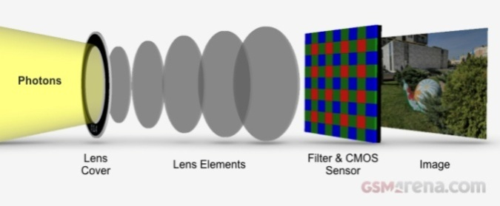In its purest form, smartphone photography is all about collecting photons (light) and converting them into electrons (image). The capabilities of the supporting hardware and software are paramount to producing high-quality images of your chosen subject.

### Image Signal Processor (ISP)

An equally important part of the smartphone camera experience is the Image Signal Processor (ISP), this is part of the silicon within a smartphones chip-set/CPU and in conjunction with the phone's software and OS provides additional enhancements and special effects when both capturing images and to the pictures once captured. These include face detection, filters, panoramic scene capturing and object identification.

Images are also geo-tagged with the GPS coordinates of where the image was captured if the phone has an internal GPS chipset.

### Quick links Camera Index

|  |  |  |
| --- | --- | --- |
| **SELFIE CAMERA** | **Single** | 24 MP, f/2.0, 26mm |
| **Features** | Leica optics |
| **Video** | 1080p@30fps |

Our Phone Specification pages have detailed camera specifications and features as shown in the Huawei P20 Pro example below:

|  |  |  |
| --- | --- | --- |
| **MAIN CAMERA** | **Triple** | 40 MP, f/1.8, 27mm, 1/1.7", OIS, PDAF/Laser AF 20 MP B/W, f/1.6, 27mm, 1/2.7", OIS, PDAF/Laser AF 8 MP, f/2.4, 80mm, 1/4", 3x optical zoom, OIS, PDAF/Laser AF |
| **Features** | Leica optics, LED flash, HDR, panorama |
| **Video** | 2160p@30fps, 1080p@60fps, 1080p@30fps (gyro-[EIS](https://www.gsmarena.com/glossary.php3?term=camera#is)), 720p@960fps |

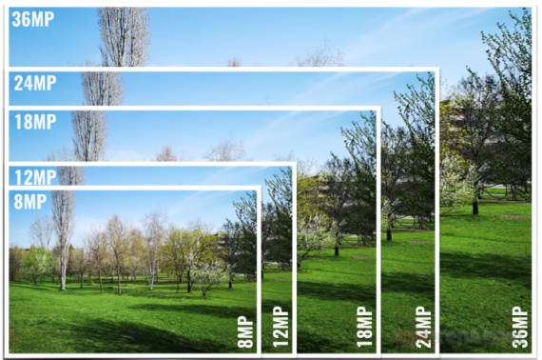

### Megapixels

The resolution of the image taken by a smartphone is measured in megapixels, a higher megapixel count doesn’t always equate to a better picture. The desire to have more and more megapixels has slowed as manufacturers focus on the quality of those megapixels captured. Accomplished by having larger pixels within the CMOS Sensor to capture more light, contrasting with a high-resolution CMOS sensor that has smaller pixels and therefore captures less light. Higher megapixel images allow ‘cropping’ of the original without losing too much detail. Higher megapixel images also ensure a higher quality image when printed, for example when printing ‘posters.’

As a comparison, when playing back images on a television or monitor - a 4K TV has an 8.3-megapixel count while an HD TV has a 2.1-megapixel number.

In most cases still images are stored either as jpeg or HEVC, these compress the image file size without losing any detail (loss-less compression). Some high-end phones capture in RAW leading to much larger file sizes. The most common format for recording video is H.264/H.265. Google and Apple provide paid ‘cloud’ storage for off-loading your photo’s and video’s over WiFi or cellular to reduce the impact on the phones internal storage.

### Aperture

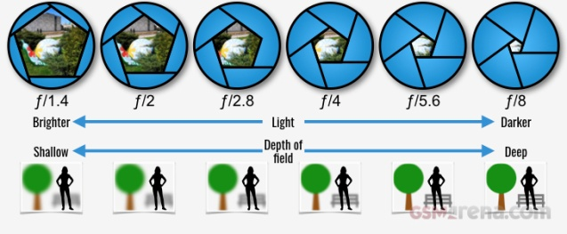The Aperture of a lens indicates how much light the lens lets in. The larger the aperture, the more light is let in, conversely a smaller aperture lets in less light. Measured in f-stops, these are inverse values, as shown in the aperture chart above, the larger the aperture the lower the f-stop number. An aperture of f/1.4 lets in more light than an aperture of f/8.

### Example of with and without Optical Image Stabilization (OIS)Electronic Image Stabilization (EIS) and Optical Image Stabilization (OIS)

Helps eliminate camera shake and produce a better quality image. Some phones successfully use Digital OIS, but the best phones use a mechanical Optical Image Stabilization system.

### Autofocus

Modern smartphones have an internal autofocus system, you can’t see this as the external Lens Covers is fixed in place. Only autofocus cameras can allow shooting of really close objects - i.e., macro shooting.

Many smartphones, when zooming in on your subject, use a digital zoom which produces a lower quality image at any given size as it’s effectively ‘cropping’ in for you. However, many flagship smartphones are using a 2nd lens to provide Optical Zoom.

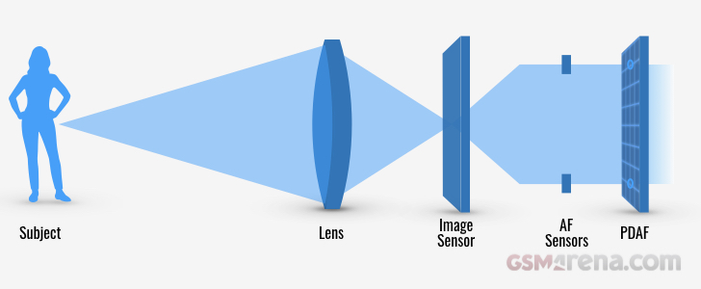**Phase Detection Auto Focus (PDAF)**

PDAF Technology uses paired masked pixels on the image sensor, designed to mimic your eyes. The ISP adjusts the camera lenses until both images are synchronized with each other and the subject deemed to be in focus.

PDAF is faster to focus that Contrast Detection Auto Focus (CDAF) and gives a sharper photo.

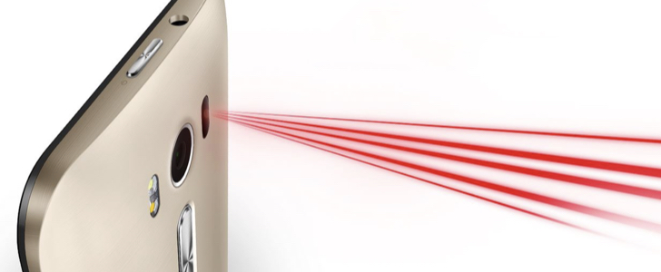**Laser Autofocus**

The camera system is outfitted with a laser transmitter and receiver. The phone uses the time taken for the laser to bounce off its subject to determine the distance to the target.

Good for taking photos quickly and in low light but less useful for landscape photos where the subject is far away from the camera.

Flash Type

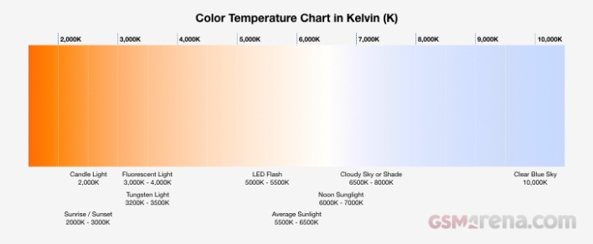A flash will brighten your subject when lighting conditions are poor.

LED flash technology was until recently the most common flash for smartphones. It’s low power, takes up little physical space and can be used continuously. However, it only illuminates a very small area, it’s slow (resulting in blurred fast moving objects), and the color temperature is often ill-suited for a given scene.

For example, an LED flash gives off light roughly at a temperature of 5,500 Kelvin (K) which equates to the temperature of Sunlight. This is why some photos may appear blue when shooting indoors in low light with an LED flash.

To provide a light temperature that better matches the environment some smartphones include multiple LED’s in a flash itself. Each LED produces a different temperature of light, and when combined can create a more natural looking image.

### HDR

HDR or High Dynamic Range attempts to add more "dynamic range" to your photographs.

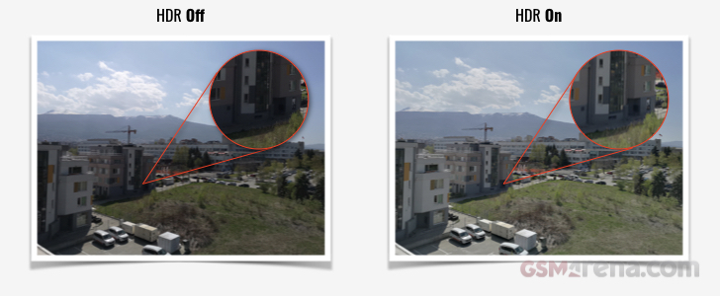As opposed to taking one photo, HDR mode takes three photos at different exposures. The CPU/ISP combine these three images together and highlight the best parts of each photo. Often your smartphone can give you the regular photo and the HDR photo. The result should better mirror what you see rather than what your smartphone lens sees.

Check out the comparison shots below to see the starked difference when looking at shadows for example.

Dependent on your subject matter and lighting conditions HDR isn't always the best solution. As such, smartphone manufactures employ AI and Auto HDR to determine the best possible use of HDR and other modes.

### Panoramic Photography

A number of steps happen behind the scenes in order for your smartphone to capture a panoramic picture. Firstly, your camera app takes a series of overlapping frames as you pan your phone across the scene or landscape. The individual frames are then 'stitched' together by your CPU/ISP to form the finished Panoramic.



Clearly, it's not as simple as described. The CPU/ISP works in conjunction with your smartphone's camera AI, gyros, and other features to not only to position each frame within the overall panoramic but also to ensure each frame matches its neighbor's exposure, color and so on. All this remarkable trickery ensures the highest quality overall image possible.

### Video

The majority of smartphones are capable of capturing 720p HD video 30 frames per second (FPS) as a minimum. The higher the FPS the smoother the video or in the case of slow-motion shooting, the slower you can make a video without losing quality. The higher the resolution and the higher the number of frames the more storage space is required.

**Common Video formats & frame rates are:**

* 1080p HD at 30 fps
* 1080p HD at 60 fps
* 4K at 24 fps
* 4K at 30 fps
* 4K at 60 fps

**Slo-mo**

* 720p HD at 240 fps
* 720p HD at 960 fps
* 1080p HD at 120 fps
* 1080p HD at 240 fps
* 1080p HD at 960 fps

For the higher 960fps smartphones, we recommend checking the manufacturer's smartphone specs to see exactly how the 960 fps works. Some phones, capture a very short burst at 960 fps - making capture trickier.

### Smartphone main or selfie cameraMain and Selfie Cameras

**Main Camera** - refers to the rear-facing camera system. The lens or lenses reside on the rear of the phone or within a backward facing pop-up camera module.

**Selfie Camera** - refers to the front-facing camera system. The lens or lenses reside on the front of the phone or within a forward facing pop-up camera housing. Additional hardware and software can be combined with the selfie cam to provide sophisticated face recognition capabilities. The Selfie Camera is also used for video conferencing applications.

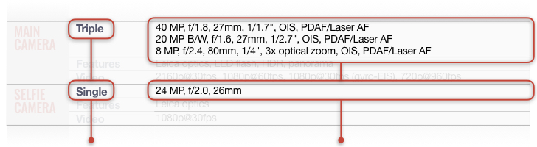Depth sensing capable camera systems can be utilized for Augmented Reality applications and animated emojis.

### Multiple Cameras

The total number of lenses contained within the Main and Selfie camera systems. Referred to as Single, Dual or Triple.

We detail each camera lens on a separate row for clarity.

Specs include the number of megapixels, aperture, focal length, sensor size, zoom type and methods of stabilization and focusing system.

In multi-lens smartphone implementations manufactures choose different lens combinations that they deem suitable for providing the best and most versatile solution. For example, a combination of wide-angle and zoom lenses.

|  |  |  |  |
| --- | --- | --- | --- |
|  |  | Vivo Y71 | Vivo Z1 Pro |
| **MAIN CAMERA** | [**Modules**](https://www.gsmarena.com/glossary.php3?term=camera) | 13 MP, f/2.2, PDAF | 16 MP, f/1.8, (wide), AF 8 MP, f/2.2, 16mm (ultrawide) 2 MP, f/2.4, depth sensor |
| [**Features**](https://www.gsmarena.com/glossary.php3?term=camera) | LED flash, HDR | LED flash, HDR, panorama |
| [**Video**](https://www.gsmarena.com/glossary.php3?term=camera) | 1080p@30fps | 2160p@30fps, 1080p@30/60fps |  |

|  |  |  |  |
| --- | --- | --- | --- |
| **SELFIE CAMERA** | [**Modules**](https://www.gsmarena.com/glossary.php3?term=camera) | 5 MP, f/2.2 | 32 MP, f/2.0 |
| [**Video**](https://www.gsmarena.com/glossary.php3?term=camera) |  | 1080p@30fps |

1. **Sound:**
   1. **Loudspeaker:**

The loudspeaker is a small sound driver fitted within a mobile phone, or other communication device, which is used to produce sound. Traditionally, loudspeakers on mobile phones are used to produce sound alerts for events such as incoming calls, incoming messages and alarms.

Since mobile phones have started doubling as portable music players in recent years, users have begun using their built-in speakers for playback of music. Acknowledging this new type of use of the mobile phone loudspeaker, manufacturers have begin to equip their music or video-centric mobiles with more powerful loudspeakers or even a pair of loudspeakers for accurate stereo reproduction and enhanced spatial effects.

Loudspeakers are also used to reproduce voice calls out loud, thus allowing users to deal with calls hands-free or even have conference calls with others in the same room (that use of the mobile phone is called a speakerphone, which is not to be confused with a loudspeaker).

Loudspeaker implementation can vary from model to model. For example, in order to save space and make phones thinner, some manufacturers don't use a dedicated loudspeaker but instead use the earpiece speaker to produce sound alerts as well.

One way or another, whether you use it for fun, conference calls or just for plain ringing, there is one single thing that's important - loudness. We had explored this in depth in our reviews besides the casual subjective remark, but in 2007 we decided it was time we took a more scientific approach.

So we got ourselves a handy piece of equipment - a digital noise/loudness meter - in order to start measuring objectively that all-important aspect of modern handsets - how loud is the loudspeaker in reality.

So, for the record, here is how our test setup goes. We do our tests in one and the same quiet room taking sound measurements with the handset loudspeaker facing the microphone at a distance of exactly 1 m.

We do three different tests. For each test we make several consecutive measurements - we usually disregard the highest and the lowest readings and we take the average value of the rest.

The three tests are as follows:

1) A phone ringing. We use an old-school ringtone, resembling the ringing of an old phone. It seems that most phones do well when we use it.

2) Pink noise. We use a sample of pink noise. Our readings with it are pretty indicative on how well the handset loudspeaker would fare with standard music. Teenagers definitely appreciate a handset that will allow them to crank up the volume as high as possible.

3) Human voice, male. This is an important test, since if you tend the use the loudspeaker for speakerphone purposes, loudness is really important, regardless of whether you are in a conference room or in your car.

|  |  |  |  |
| --- | --- | --- | --- |
| **SOUND** |  | Vivo Y71 | Vivo Z1 Pro |
| **Loudspeaker** | Yes | Yes |

* 1. **Audio jack:**

A common connector for plugging in a standard pair of music headphones such as the ones found on music players, computers and most other electronic devices with audio outputs.

It can support stereo and/or microphone, depending on the number of separate connector rings on the jack.

Some phones offer only a 2.5 mm jack, which is a smaller variety of the same principle.

Headphones supplied with mobile phones usually have a mic somewhere along the cable and a remote button that allows for managing calls without using the phone.

|  |  |  |  |
| --- | --- | --- | --- |
| **SOUND** |  | Vivo Y71 | Vivo Z1 Pro |
| **3.5mm jack** | Yes | Yes |
|  | Active noise cancellation with dedicated mic | Active noise cancellation with dedicated mic |

Some manufacturers opt for placing a 3.5mm audio jack on this remote control instead of directly on the phone itself. The reason for this is that 3.5mm jacks take up quite a lot of internal space; plus, in this way the user gets to keep the remote control/mic functionality while using third-party headphones.

1. **Communications:**
2. **Wi-Fi**

Wi-Fi is a WLAN (Wireless Local Area Network) technology. It provides short-range wireless high-speed data connections between mobile data devices (such as laptops, PDAs or phones) and nearby Wi-Fi access points (special hardware connected to a wired network).

The older variant of Wi-Fi, 802.11g, is capable of providing speeds of up to 54Mbps and is backwards compatible with 802.11b (providing up to 11Mbps).

The more recent standard is called 802.11n (offering speeds of up to 150Mbps per channel or up to 600Mbps in total). It can be used in the 2.4 GHz or 5 GHz frequency bands, though a receiver needs to have dual-band antenna to operate on both.

2013 saw the birth of the latest (so far) Wi-Fi ac standard. It allows for speeds of up to 500 Mbps per channel and over 1Gbps in total. Wi-Fi 802.11ac operates only on the 5GHz band.

Wi-Fi is much faster than any data technologies operating through the cellular network like GPRS, EDGE and even UMTS and HSDPA.

The range covered by a Wi-Fi access point is from 30 to 100 meters indoors while outdoors a single access point can cover about 650 meters.

|  |  |  |  |
| --- | --- | --- | --- |
| **COMMS** |  | Vivo Y71 | Vivo Z1 Pro |
| **WLAN** | Wi-Fi 802.11 a/b/g/n/ac, dual-band, Wi-Fi Direct, hotspot | Wi-Fi 802.11 b/g/n, Wi-Fi Direct, DLNA, hotspot |

1. **Bluetooth:**

Bluetooth is a wireless protocol for exchanging data over short distances from fixed and mobile devices, creating personal area networks.

There are two important parameters of Bluetooth devices - class and supported profiles.

"Class" signifies the distance at which a Bluetooth connection is possible. Most mobile devices are Class 2, which means they have a range of up to 10 m. Class 1 devices are rare and have a range of up to 100 feet.

A "profile" is a type of Bluetooth connection. The most common are the Headset (HSP) and Handsfree (HFP) profiles that enable the device to connect to a wireless headset or handsfree.

Some other profiles are OBEX (OBject EXchange) which allows transfer of files, contacts and events; A2DP, which adds support for streaming of stereo sound and AVRC, which allows remote control of playback.

|  |  |  |  |
| --- | --- | --- | --- |
| **COMMS** |  | Vivo Y71 | Vivo Z1 Pro |
| **Bluetooth** | 4.2, A2DP, LE | 5.0, A2DP, LE |

1. **GPS (Global Positioning System)**

Global Positioning System was developed by the United States' Department of Defense. It uses between 24 and 32 Medium Earth Orbit satellites that transmit precise microwave signals. This enables GPS receivers to determine their current location, time and velocity. The GPS satellites are maintained by the United States Air Force.

Additional countries with their own satellite positioning systems are:

* Russia - GLONASS (Global Navigation Satellite System)
* European Union - Galileo (Global Navigation Satellite System)
* China - BeiDou Navigation Satellite System
* Japan - QZSS (Quasi-Zenith Satellite System)

GPS is often used by civilians as a navigation system. On the ground, any GPS receiver contains a computer that "triangulates" its own position by getting bearings from at least three satellites. The result is provided in the form of a geographic position - longitude and latitude - to, for most receivers, within an accuracy of 10 to 100 meters. Software applications can then use those coordinates to provide driving or walking instructions.

Getting a lock on by the GPS receivers on the ground usually takes some time especially where the receiver is in a moving vehicle or in dense urban areas. The initial time needed for a GPS lock is usually dependent on how the GPS receiver starts. There are three types of start - hot, warm and cold.

The **hot start** is when the GPS device remembers its last calculated position and the satellites in view, the almanac used (information about all the satellites in the constellation), the UTC Time and makes an attempt to lock onto the same satellites and calculate a new position based upon the previous information. This is the quickest GPS lock but it only works if you are generally in the same location as you were when the GPS was last turned off.

The **warm start** is when the GPS device remembers its last calculated position, almanac used, and UTC Time, but not which satellites were in view. It then performs a reset and attempts to obtain the satellite signals and calculates a new position.

The receiver has a general idea of which satellites to look for because it knows its last position and the almanac data helps identify which satellites are visible in the sky. This takes longer than a hot start but not as long as a cold start.

And finally – the **cold start** is when the GPS device dumps all the information, attempts to locate satellites and then calculates a GPS lock. This takes the longest because there is no known information.

The GPS receiver has to attempt to lock onto a satellite signal from any available satellites, basically like polling, which takes a lot longer than knowing which satellites to look for. This GPS lock takes the longest.

In an attempt to improve lock times, cellphone manufacturers and operators have introduced the Assisted GPS technology, which downloads the current ephemeris for a few days ahead via the wireless networks and helps triangulate the general user’s position with the cell towers thus allowing the GPS receiver to get a faster lock at the expense of several (kilo)bytes.

|  |  |  |  |
| --- | --- | --- | --- |
| **COMMS** | **GPS** | Vivo Y71 | Vivo Z1 Pro |
| Yes, with A-GPS, GLONASS | Yes, with A-GPS, GLONASS, BDS |

1. **IrDA (Infrared Data Association)**

* A standard for transmitting data using an infrared port. Transfer speeds are roughly the same as traditional parallel ports.
* The industry group that created the IrDA technical standard.

Infrared connectivity is an old wireless technology used to connect two electronic devices. It uses a beam of infrared light to transmit information and so requires direct line of sight and operates only at close range.

IR was superseded by Bluetooth, which has the advantage of operating at longer distances (around 30 feet) and being omni-directional.

Many home devices such as TVs and DVD players still use IR remote controls. Some smartphones are capable of using their IR port to control these devises but that usually requires third-party software.

|  |  |  |  |
| --- | --- | --- | --- |
| **COMMS** |  | Vivo Y71 | Vivo Z1 Pro |
| **Infrared port** | No | No |

1. **FM Radio**

The built-in FM radio tuner is now considered a basic feature. It allows the user to listen to most of the live-broadcasted FM radio stations. Almost all phones with FM radio tuner require a wired headset to be connected to the unit as it’s used as an antenna.

Most FM radio tuners can receive basic radio station info over RDS. The use of FM radio does not interfere with the network carrier and it’s free.

Nokia enhance their FM radio interfaces with the Visual Radio enhancement that adds visuals and text as an additional info layer to normal radio broadcasts.

A presentation of graphics and text, synchronized to the audio programming, gets downloaded to the phone over a data connection; the FM transmission chain is unaffected by the addition of Visual Radio.

Here's the type of content that Visual Radio can offer:

* Information on the song and artist currently playing on air
* View images related to presenters or news stories
* A weather map during the weather broadcast
* News, weather and traffic alerts while songs are playing
* Listen in to a talk show and see what has been discussed so far
* Join in audience votes, Big Brother style
* Participate in on-air competitions

You can only use the Visual Radio enhancement via a cellular data connection, as using it over Wi-Fi is not an option.

|  |  |  |  |
| --- | --- | --- | --- |
| **COMMS** |  | Vivo Y71 | Vivo Z1 Pro |
| [**Radio**](https://www.gsmarena.com/glossary.php3?term=fm-radio) | FM radio | FM radio |

1. **USB (Universal Serial Bus)**

USB is a standard for a wired connection between two electronic devices, including a mobile phone and a desktop computer. The connection is made by a cable that has a connector at either end. One end, the one that plugs into the computer, is the same across all USB cables while the one that plugs into the mobile device can be of various types such as miniUSB, microUSB or a proprietary connector.

USB version 1.1 provides maximum speeds of up to 1.5 MB/s while the current version 2.0 is about 40 times faster. The versions are backwards compatible and the speed is limited by the slower device. Transferring data may require drivers to be installed on the desktop computer but some phones offer "mass storage" mode which means they appear as thumb drives to the computer and no special drivers are needed.

In addition to their data transferring application, USB cables also carry an electric charge that can be used to power peripherals (such as USB mice or keyboards), and many mobile phones can be charged through their USB port.

|  |  |  |  |
| --- | --- | --- | --- |
| **COMMS** |  | Vivo Y71 | Vivo Z1 Pro |
| **USB** | microUSB 2.0, USB On-The-Go | microUSB 2.0, USB On-The-Go |

1. **Sensors**

Smartphones today come with a wealth of sensors to facilitate a better user experience, provide apps with enhanced information about the world around the phone and provide robust and increased battery life.

**Proximity Sensor**

Detects when an object is near to the phone. Most commonly used to sense when a phone is held up to the users ear to turn off the display. This saves both battery life and prevents accidental screen touches.

**Accelerometer and gyroscope**

Accelerometers in mobile phones are used to detect the orientation of the phone. The gyroscope, or gyro for short, adds an additional dimension to the information supplied by the accelerometer by tracking rotation or twist.

An accelerometer measures linear acceleration of movement, while a gyro on the other hand measures the angular rotational velocity. Both sensors measure rate of change; they just measure the rate of change for different things.

In practice, that means that an accelerometer will measure the directional movement of a device but will not be able to resolve its lateral orientation or tilt during that movement accurately unless a gyro is there to fill in that info.

With an accelerometer you can either get a really "noisy" info output that is responsive, or you can get a "clean" output that's sluggish. But when you combine the 3-axis accelerometer with a 3-axis gyro, you get an output that is both clean and responsive in the same time."

Accelerometers are also used to provide 'steps' information for a vendors 'health' application.

**Digital compass**

The digital compass that's usually based on a sensor called the magnetometer and provides mobile phones with a simple orientation in relation to the Earth's magnetic field. As a result, your phone always knows which way is North so it can auto rotate your digital maps depending on your physical orientation.

**Barometer**

The barometer assists the GPS chip inside the device to get a faster lock by instantly delivering altitude data. Additionally,

the barometer can be utilized to provide 'floors climbed' information to a phones 'health' app.

With the advent of more accurate indoor navigation, the barometer can assist in determine what floor a user is on within an airport for example.

**Biometrics**

Biometric related sensors provide levels of enhanced security by capturing and validating human related metrics. Including Finger Print recognition, IRIS (eye) scanning and full facial recognition.

Biometric sensors provide a more secure but more convenient way to unlock phones and pay for purchases.

Additionally, biometric sensors can be used to collect a users heart rate and SpO2 (the estimate of arterial oxygen saturation) for use within a vendors 'health' application.

**Augmented & Virtual Reality**

The highly accurate sensors detailed above, when combined with the powerful CPU & GPU's of modern smart phones, allow very realist and responsive Virtual Reality applications to be created. When the sensors are combined with a smartphones camera they facilitate Augmented Reality applications.

|  |  |  |  |
| --- | --- | --- | --- |
| **FEATURES** |  | Vivo Y71 | Vivo Z1 Pro |
| [**Sensors**](https://www.gsmarena.com/glossary.php3?term=sensors) | Accelerometer, gyro, proximity, compass | Fingerprint (rear-mounted), accelerometer, gyro, proximity, compass |

# Battery Charging

The circuitry to recharge the batteries in a portable product such a mobile phone plays an important part in determining the battery longevity and the practicalities of using the product on a daily basis.

The charging protocol (how much voltage or current for how long, and what to do when charging is complete) depends on the size and type of the battery being charged.

The modern battery chargers adapt the charging parameters dynamically based on the level of charging the battery has reached. An empty battery can be charged faster without any safety risk. This is why most benchmarks for charging speed (ours included) quote the battery charging level reached after a 30-minute charging session on an empty battery.

With basic chargers outputting 5V/1A equalling to 5W of power, anything faster than that is considered quick or fast charging.

### Quick charging

Quick charging field is still very much fragmented and almost every manufacturer has its own solution - most of the time, including proprietary tech.

The most common solution is the 5V/2A charging which delivers 10W of power and pretty much every phone other there supports this charging rate. The real quick charging starts from there and up.

Smartphones utilizing Qualcomm chipsets can make use of Qualcomm's QuickCharge protocol. It's been through a few generations already with the latest one being **QuickCharge 4+**. It is backward compatible with the previous generations and the most common implementations peak at 18W of power output. Motorola is using this standard for its phones even though they are marketing it as TurboPower and QuickCharge is not mentioned anywhere.

Similarly to Qualcomm, MediaTek has also introduced its own charging standard called **Pump Express**, which is supported by phones using the company's chipsets and it requires its own set of proprietary chargers. The latest generation of the standard is PumpExpress 3.0 and it utilizes a USB-C connector for the charging cable. Pump Express+ 2.0 is available as well as a more budget solution and it allows the use of a microUSB connector.

**USB Power Delivery** is another quick charging standard and this one is not limited to a particular hardware manufacturer. It doesn't require proprietary hardware though it does require the use of USB-C to USB-C cable. The maximum power output is 100W because there are even laptops that rely on this standard for charging. The current implementations in smartphones however only go as high as 18W of power output.

Oppo, Vivo and OnePlus share some of their intellectual property and R&D and as a result, their phones use similar quick charging solutions. Oppo calls it **VOOC Flash charge**, Vivo calls it just **Fast battery charging**, while OnePlus used to call theirs **Dash charge** (now renamed to just OnePlus Fast Charge for legal reasons). All three versions output 18-20W of power.

But since the three manufacturers are spearheading the quick charge revolution, in 2018 they came up with even faster implementations so they introduced new names as well making things a bit more confusing for the inexperienced users. Oppo's **Super VOOC Flash charge**can output 50W of power. Vivo's **Dual-Engine Fast Charge** can output 22.5W of power. And finally, OnePlus's **Warp charge** can deliver up to 30W.

Huawei also has a proprietary fast battery charging solution in their top-tier smartphones called **SuperCharge**, which is capable of outputting 40W of power but their more common implementations provide up to 22.5W of power.

Meizu's **mCharge** solution is proprietary as well and is already available in a few of their higher models. It can deliver up to 24W of power. Meizu has also demoed their future Super mCharge solution which can deliver up to 55W of power but it's yet to release a smartphone integrating it as of the time of writing this.

### Wireless charging

Wireless (or inductive) charging uses an electromagnetic field to transfer energy between two objects through electromagnetic induction. Induction is achieved by placing a device which is equipped with the induction coil directly onto a dedicated charging station (or charging pad).

While there used to be at least a few competing wireless charging standards in the past, nowadays the entire mobile industry has moved to using Qi (pronounced "chee").

Much like with the regular wired charging - wireless charging can be performed at different rates. The nominal power output of a Qi charging pad is 5W but faster chargers can already pump out up to 15W of power to phones which support it.

Regardless of the maximum power output supported by the charging pad and the smartphone, the Qi standard demands that all the hardware is backward compatible so regardless the supported revision - any Qi pad is compatible with all Qi-enabled devices.

1. **Stand-by time (battery life)**

Stand-by time is the officially quoted longest time that a single battery charge will last when the phone is constantly connected to the GSM network but is not in active use.

The stand-by time is highly dependent on the cellular network environment, such as the distance to the closest GSM cell tower (base station). Moving the phone (as in a vehicle) also negatively affects battery life.

Manufacturers measure talk time in controlled conditions and the quoted numbers are rarely reached in real-life scenarios. These numbers are best used as reference when comparing phones from the same manufacturer because battery life measurement methodology will probably vary from manufacturer to manufacturer.

Quite often you will find the Stand-by time field in the specification pages of new phones empty as the manufacturers sometimes fail to disclose the info at the official announcement. Later on when the handset hits the market, the figures are usually revealed and accordingly, we take the care to add them to the database.

1. **Talk time (battery life)**

Talk time is the officially quoted longest time that a single battery charge will last when you are constantly talking on the phone.

The talk time is highly dependent on the cellular network environment such as the distance to the closest GSM cell tower. Moving fast while talking (as in a vehicle) also negatively affects battery life.

Manufacturers measure talk time in controlled conditions and the quoted numbers are rarely reached in real-life scenarios. These numbers are best used as reference when comparing phones from the same manufacturer because battery life measurement methodology will probably vary from manufacturer to manufacturer.

Quite often you will find the Talk time field in the specification pages of new phones empty as the manufacturers sometimes fail to disclose the info at the time of the official announcement. Later on, when the handset hits the market, the figures are usually revealed and accordingly, we take the care to add them to our database.

|  |  |  |  |
| --- | --- | --- | --- |
|  |  | Vivo Y71 | Vivo Z1 Pro |
| **BATTERY** |  | Non-removable Li-Po 3360 mAh battery | Non-removable Li-Ion 5000 mAh battery |
| [**Charging**](https://www.gsmarena.com/glossary.php3?term=battery-charging) |  | Fast battery charging 18W |

**Quotations for both the mobiles**

